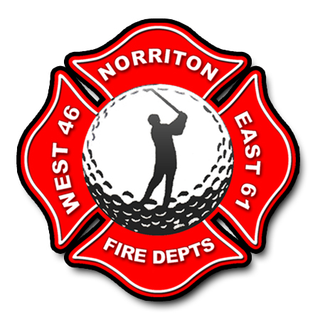
Dear Business Owner,

It’s that time again for the 22nd annual East/West Norriton Fire Companies Golf Outing. This event is co-sponsored by the Jefferson Fire Co No1 and the Norriton Engine Company. The outing will be held on Saturday August 9, 2025, at the Jeffersonville Golf Club 2400 W. Main St Jeffersonville.

The outing is scheduled to start with a shotgun start at 1:00 p.m. In past years we have sold out for golfers (130) and have had numerous Hole and Corporate Sponsors. Once again, we are asking for your support in Hole Sponsorships, this event would not be successful without the continued support from our area business leaders. To be a Hole Sponsor for this year’s outing the cost is $100.00 per hole.

This year we are also offering a Corporate Sponsorship; the cost for this is $500.00. Being a Corporate Sponsor, you get a Hole Sponsorship, your Company logo on the back of a T-Shirt designating a 2025 Corporate Sponsor. Remember every golfer and worker will be given a T-Shirt the day of the outing. This would be approximately 150 T-Shirts handed out the day of the outing. Corporate Sponsorship must be received by July 21, 2025.

The money raised from this event helps defray the costs of equipment purchased by each of the fire companies throughout the year. Both fire companies are volunteer whether it is 12 noon or 12 midnight we still respond to the needs of our residents and businesses. So once again we are asking for your support in sponsoring a Hole or becoming a Corporate Sponsor at the 22nd Annual East/West Norriton Fire Companies Golf Outing.

Thanks Again,
The 2025 Golf Committee

Make Checks Payable To: JEFFERSON FIRE CO
Send To: Jefferson Fire Co
85 School Lane
Norristown, Pa 19403
Attn: GOLF OUTING
Any questions please call (610) 539-3990 (Jefferson Fire Co)

